Atomic Structure

Element: matter that is composed of one type of atom.

Elements are abbreviated in scientific shorthand- either a letter or a pair of letters called a chemical symbol. Ex- Aluminum =Al Copper=Cu

Atom- smallest piece of matter that still has the properties of the element.

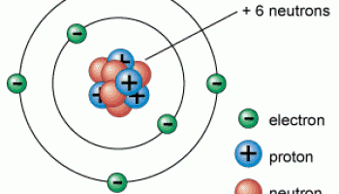
Protons- positive charge (1+)

Neutrons- no charge-neutral

Electrons- negative charge (1-)

Nucleus- located in center of atom
Consist of protons & neutron.
Electrons surround the nucleus

Electron Cloud-current model which shows electrons traveling in specific energy levels around a nucleus, electrons closest to nucleus have low energy, electrons farther away have high energy.

Electrons in Energy Levels
Energy Level in Atom Max # of Electrons

